**OUTREACH SCHOOLS EXAMINATION BOARD**

 **BEGINNING OF TERM III EXAMINATION 2024**

**PRIMARY THREE**

**LITERACY 1A**

**A**

**B**

**For Examiner’s**

**use only**

**TOTAL**

***Time Allowed: 2hours 15 minutes***

**Name: ______________________________________________**

**School: _____________________________________________**

**Class: ___________________________________________**

**SECTION: A (40 MARKS)**

1. __________________________________is the study of living things and non-living things.
2. Which immunisable disease causes lameness to children?

________________________________________________________________________

1. What happens to a seed when it gets oxygen moisture and warmth?

________________________________________________________________________

1. Which part of a seed stores its food?

________________________________________________________________________

1. Why is a fish called a living thing?

________________________________________________________________________

1. To which group of living things does man belong?

________________________________________________________________________

1. Which domestic anima provides wool and mutton?

________________________________________________________________________

1. On which part of a n insect are spiracles found?

________________________________________________________________________

1. Name the type of soil best for crop growing.

________________________________________________________________________

1. Draw and name one animal which lives in water.

_______________________________________

1. A fry is to fish as ____________________________________is to frog.
2. Which part of a cabbage plant do we eat?

________________________________________________________________________

1. How many legs has a centipede and a millipede?

________________________________________________________________________

1. Which insect produces bad smell for protection?

________________________________________________________________________

1. State one way of keeping your body clean.

________________________________________________________________________

1. Which part of a cassava plant makes its food?

________________________________________________________________________

1. Why should you sleep under a mosquito net?

________________________________________________________________________

1. What do we call a mixture of gases?

________________________________________________________________________

1. ___________________________is the carrying away of top soil by running water or wind?
2. Which gas occupies the largest amount of space in the atmosphere?

________________________________________________________________________

1. What happens to water when heated?

________________________________________________________________________

1. How does a mushroom reproduce?

________________________________________________________________________

1. Give one use of bees to man.

________________________________________________________________________

1. Which property of air is shown in the diagram below?

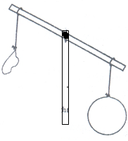

________________________________________________

1. Why should water for drinking be boiled?

________________________________________________________________________

1. Which clouds bring rain?

________________________________________________________________________

1. In which direction will your shadow be when the sun is in the East?

________________________________________________________________________

1. Why is it bad to build a house in a swamp?

________________________________________________________________________

1. On which planet do you live?

________________________________________________________________________

1. Name one example of a liquid.

________________________________________________________________________

1. How many stages has a grasshopper?

________________________________________________________________________

1. Where does a mosquito lay its eggs?

________________________________________________________________________

1. Mention any one non flowering plant.

________________________________________________________________________

1. Why is a housefly called an insect?

________________________________________________________________________

1. Write down one activity done by the farmer during the wet season.

________________________________________________________________________

1. Give one process involved in the formation of rainfall.

________________________________________________________________________

1. Name the gas used to preserve tinned food and drinks.

________________________________________________________________________

1. What type of food is made by plants?

________________________________________________________________________

1. ____________________________are insects which live and work together?
2. Apart from absorbing water, how else are roots important to the plant?

________________________________________________________________________

**SECTION B**

1. a) Name the garden tools shown below

**i**)

**ii)**

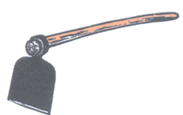

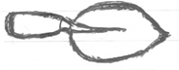

b) Name the garden tool a farmer uses to cut big trees.

________________________________________________________________________

c) Why should a farmer clean his garden tools after use?

________________________________________________________________________

1. Write down the animals which uses each of the following weapons for protection;

i) fangs___________________________ ii) horns ______________________________

iii) sting __________________________ iv) dorsal fin __________________________

1. a) Name any two natural sources of light.

i) ______________________________________________________________________

ii)_______________________________________________________________________

b) Why is the moon not regarded a source of light?

________________________________________________________________________

1. In what way is sunlight useful to plants?

________________________________________________________________________

1. a) What are non-living things?

________________________________________________________________________

b) Draw and one any one non-living thing in your classroom.

_______________________________________________

c) Write down any two groups of living things.

i)______________________________________________________________________

(ii)______________________________________________________________________

1. **Study the diagram below and use it to answer questions that follow**

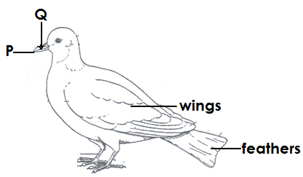

1. Name part **P** and **Q** to the animal above.

i)**P**____________________________________(ii)**Q** ___________________________

1. Mention one importance of feathers to birds.

________________________________________________________________________

1. Give one reason why people keep birds.

________________________________________________________________________

1. a) Give one natural source of water.

________________________________________________________________________

b) Mention any one artificial source of water.

________________________________________________________________________

c) State one use of water in our environment.

________________________________________________________________________

1. Suggest one way in which water gets contaminated.

________________________________________________________________________

1. T**he diagram shows pars of a flowering plant. Name them.**

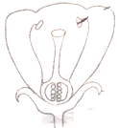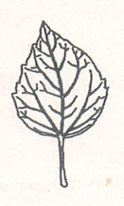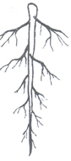

**A**

**B**

**C**

b) Which letter shows the part of a flowering plant used for reproduction?

________________________________________________________________________

1. a) Mention two types of germs.
2. ___________________________________________________________________
3. ___________________________________________________________________

b) Write down two places where germs are found.

i)_______________________________________________________________________ ii)_______________________________________________________________________

1. **The diagram shows the life cycle of a house fly**
2. 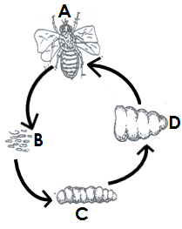Name stages labelled **A** and **B**.

i) **A**________________________________________________

ii) **B**________________________________________________

1. What type of life cycle is shown in the diagram above?

__________________________________________________

1. Which stage in the life cycle above is useful in a latrine?

____________________________________________________

1. a) _______________________________is the first help given to an injured person before taking him to hospital.

b) Name two items found in a First Aid box.

i) ______________________________________________________________________

ii)______________________________________________________________________

c) How is a First Aid box useful in a school?

________________________________________________________________________

1. **Use the diagrams to answer questions.**
2. 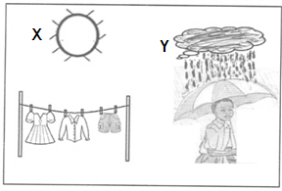Name the element of weather shown in diagram **X** and **Y**.

i) **X**____________________________________

ii) **Y**___________________________________

b) Which type of weather is shown in diagram **Y** above?

_______________________________________

c) Give one use of the sun to people.

________________________________________________________________________

1. a) Mention two gases which make up air.

i) ______________________________________________________________________

ii) ______________________________________________________________________

1. What is wind?

________________________________________________________________________

1. Mention one danger of wind to a farmer.

________________________________________________________________________

1. Name the breathing organs of each of the following;

i)fish___________________________________ (ii) spider ______________________

ii)insects________________________________(iii) earthworm__________________

1. a) Name the following crops.

|  |  |
| --- | --- |
|  |  |
|  |  |

b) Give any two ways of caring for plants in the diagram.

i) ______________________________________________________________________

ii)_______________________________________________________________________

1. a) Mention two seasons found in Uganda.

i) ____________________________________________________________________

ii) ___________________________________________________________________

1. What do we call a long period of time without rain?

______________________________________________________________________

1. Give one importance of rain to people.

______________________________________________________________________

**Good Luck**